CIS 249
Grading Rubric – Microcomputer
Operating Systems

Name: _____________________________

Chapter: __________________

Description | Pts | Your Score
TOTAL POSSIBLE POINTS:

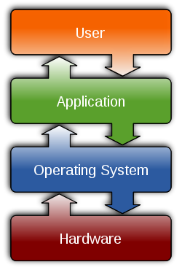
YOUR SCORE: _______________

